**Introduction**

**Welcome**

Android is installed on more mobile devices than any other operating system. At last count, Android was installed on over 1.4 billion active monthly devices. With an install base that large, developing apps for Android is a very exciting and potentially lucrative opportunity. The Android ecosystem includes the Android OS for smartphones and tablets. It also includes Chrome OS devices that support Android apps and devices from Amazon, like the Fire tablet and other products. My name is Doug Winnie and in this course I'll introduce the basics of building apps for Android.

We'll cover the Android ecosystem, build a simple one-screen game and dive into XML and Java to build the game. After you're finished this course, you'll have a project that you can modify and expand upon, with some suggestions and ideas on where you can take it further. So with that, let's get started building our first app for Android.

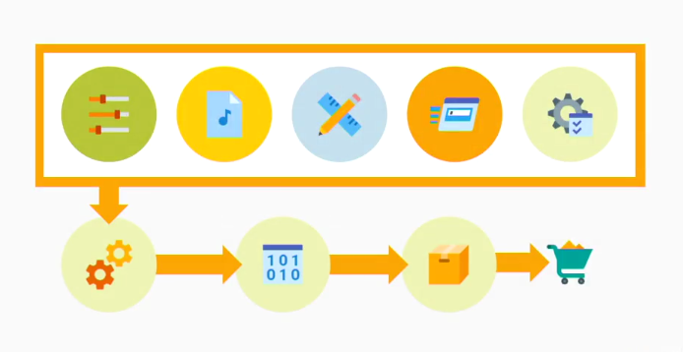

Figure: Android ecosystem